# Questions 1

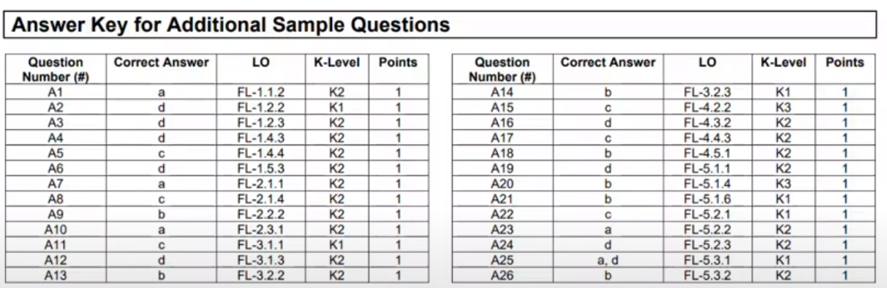

## Question 1

FL Review part2 - start at 3:00

Q1

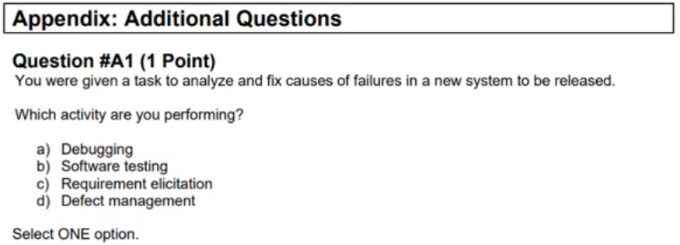

Q1 - Answer

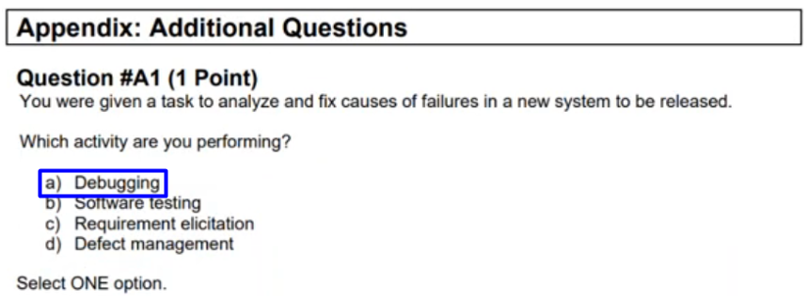

## Question 2

FL Review part2 - start at 3:39

Q2

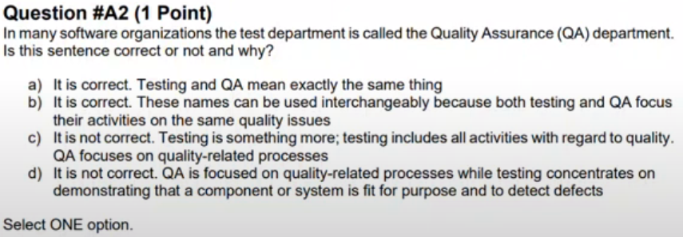

Q2 - Answer

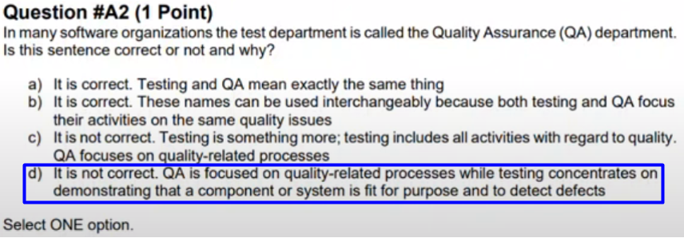

## Question 3

FL Review part2 - start at 7:51

Q3

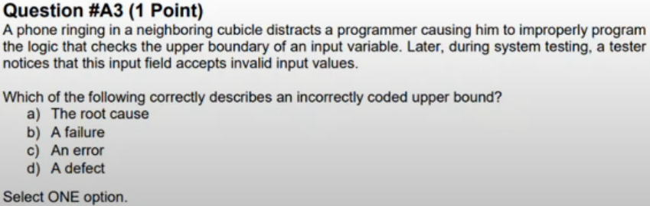

Q3 - Answer

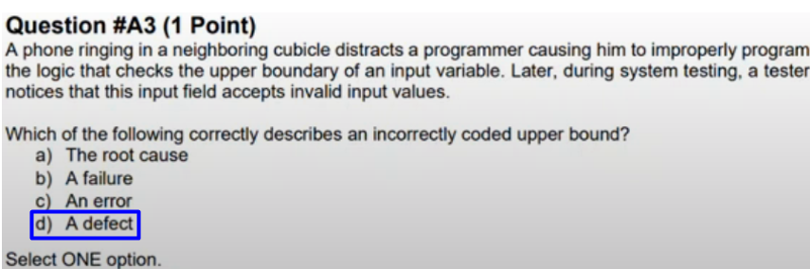

## Question 4

FL Review part2 - start at 9:27

Q4

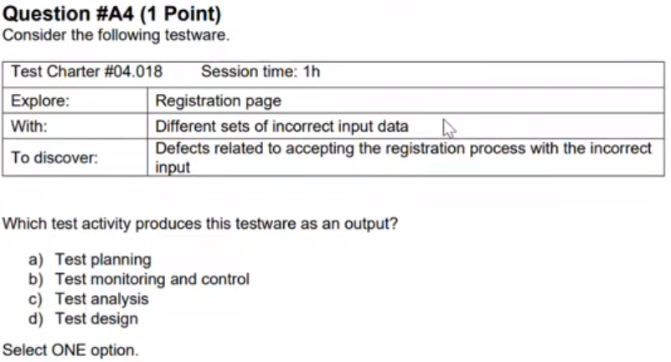

Q4 - Answer

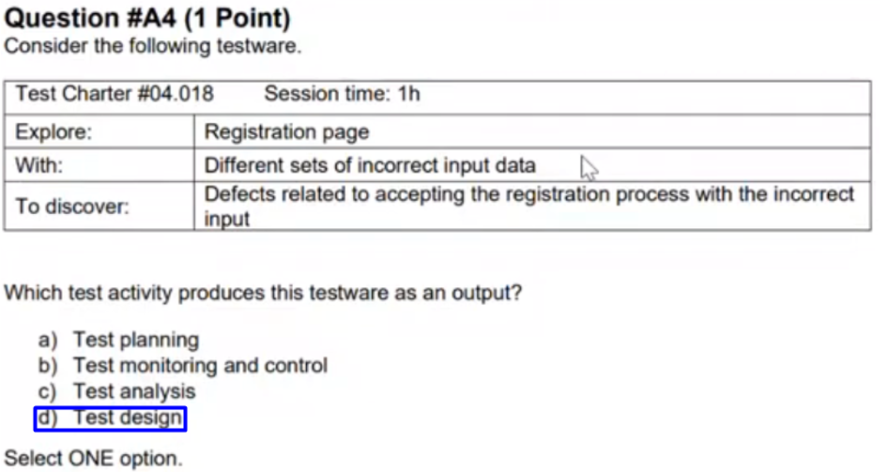

## Question 5

FL Review part2 - start at 13:14

Q5

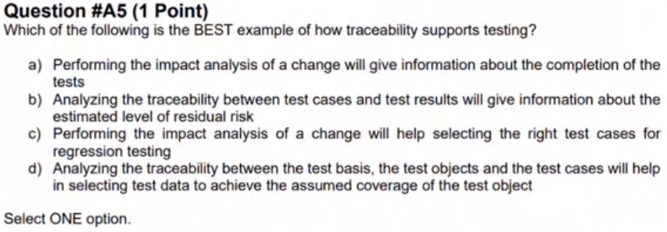

Q5 - Answer

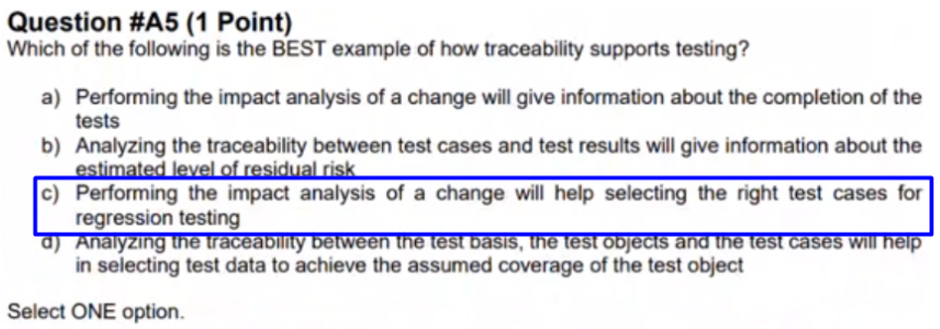

## Question 6

FL Review part2 - start at 17:07

Q6

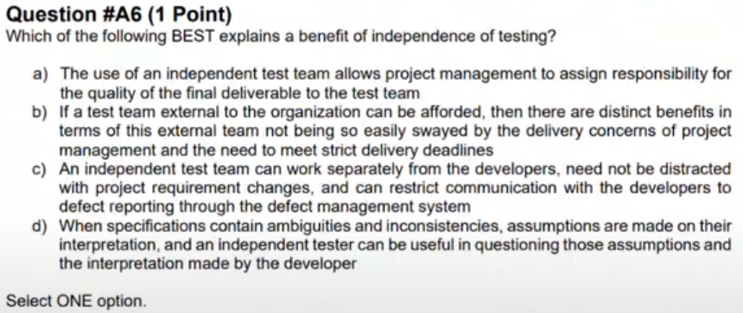

Q6 - Answer

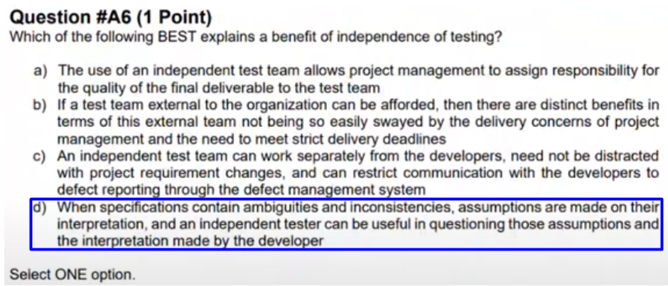

## Question 7

FL Review part2 - start at 22:36

Q7

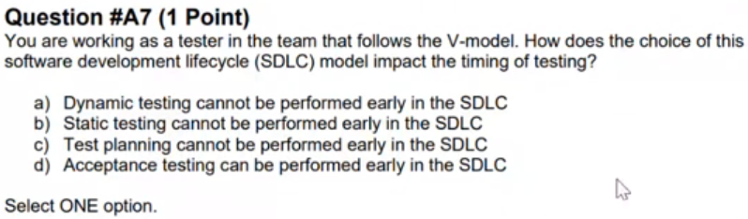

Q7 - Answer

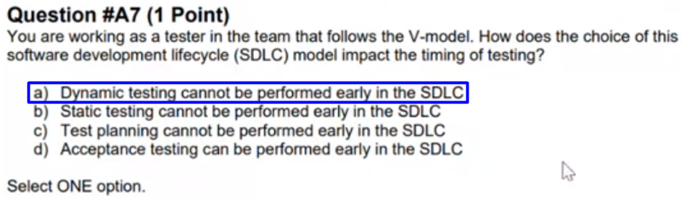

## Question 8

FL Review part2 - start at 26:29

Q8

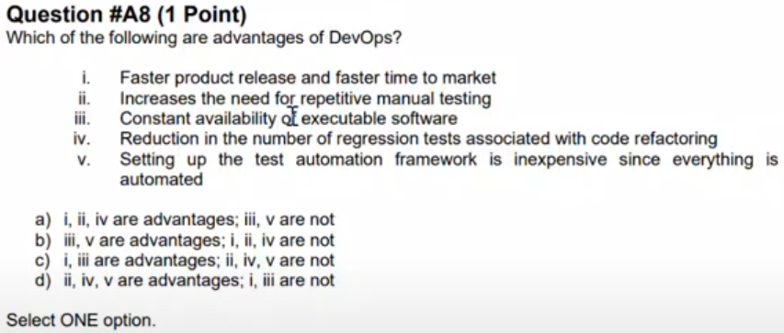

Q8 - Answer

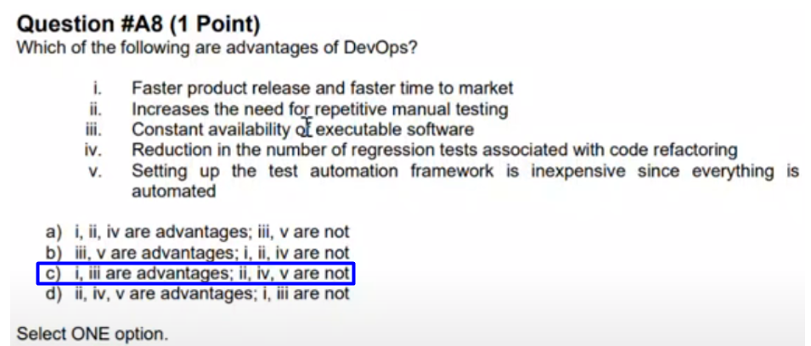

## Question 9

FL Review part2 - start at 31:46

Q9

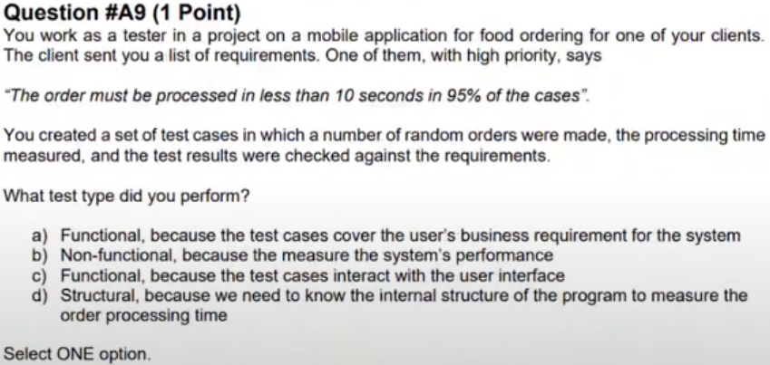

Q9 - Answer

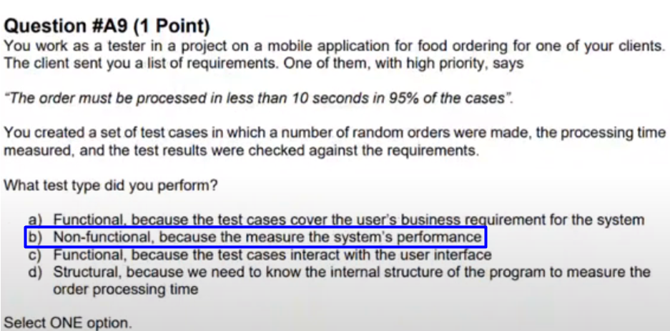

## Question 10

FL Review part2 - start at 33:39

Q10

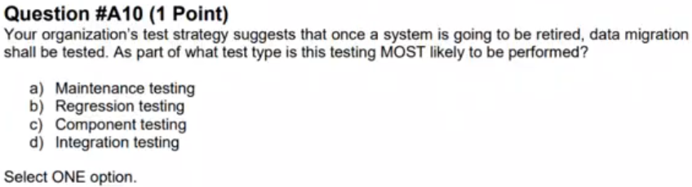

Q10 - Answer

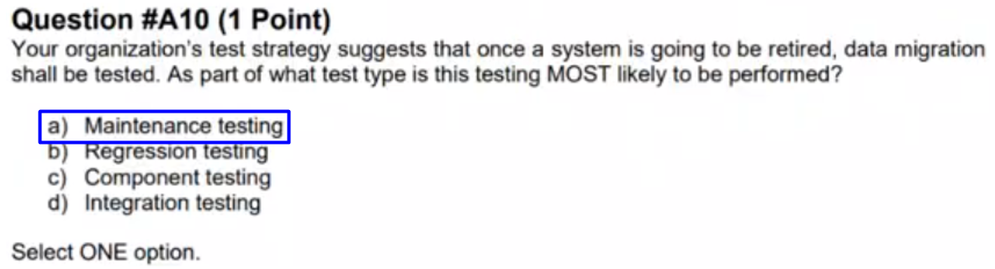

## Question 11

FL Review part2 - start at 34:20

Q11

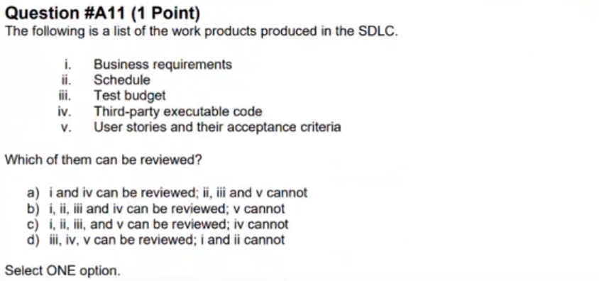

Q11 - Answer

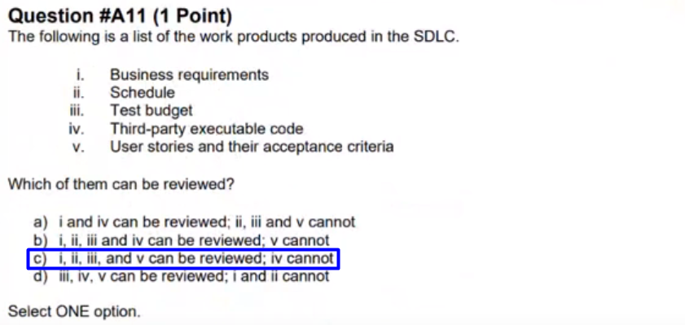

## Question 12

FL Review part2 - start at 36:04

Q12

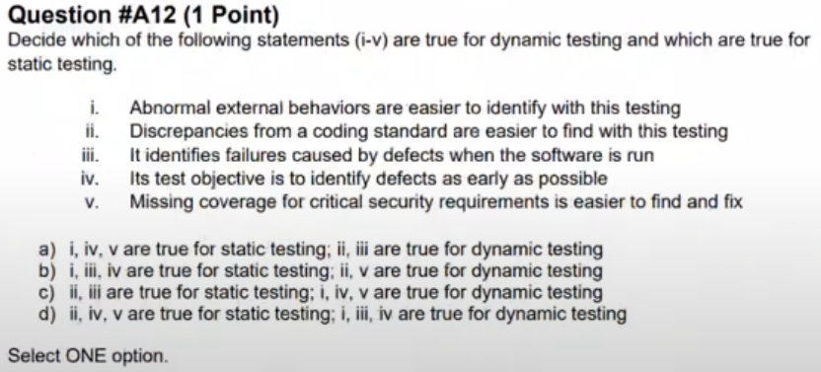

Q12 - Answer

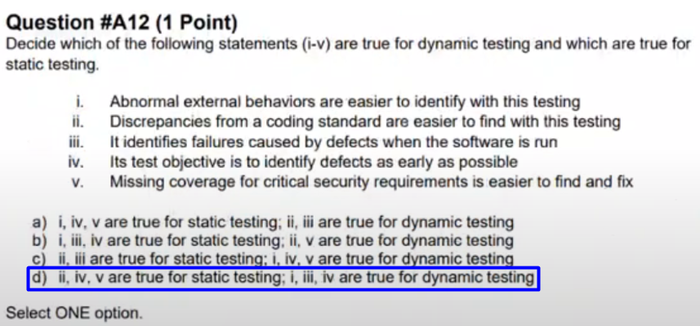

## Question 13

FL Review part2 - start at 45:16

Q13

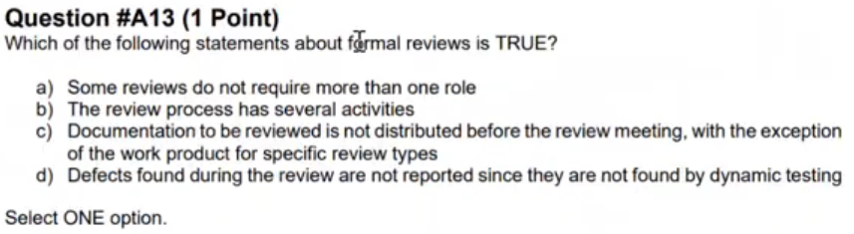

Q13 - Answer

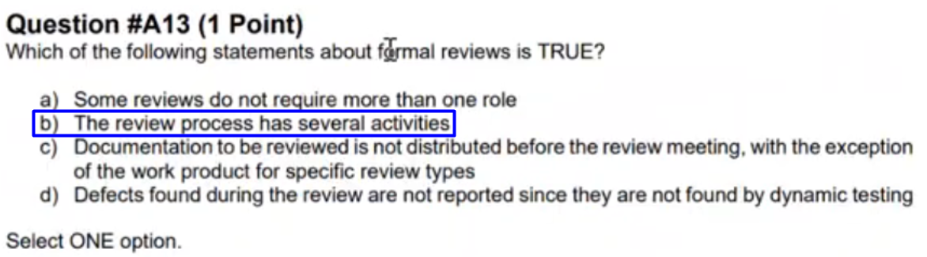

## Question 14

FL Review part2 - start at 46:24

Q14

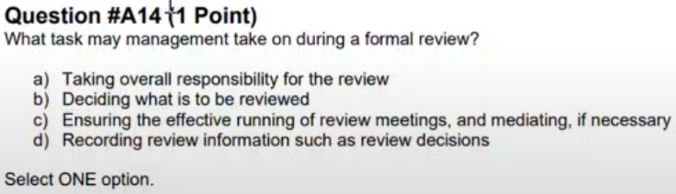

Q14 - Answer

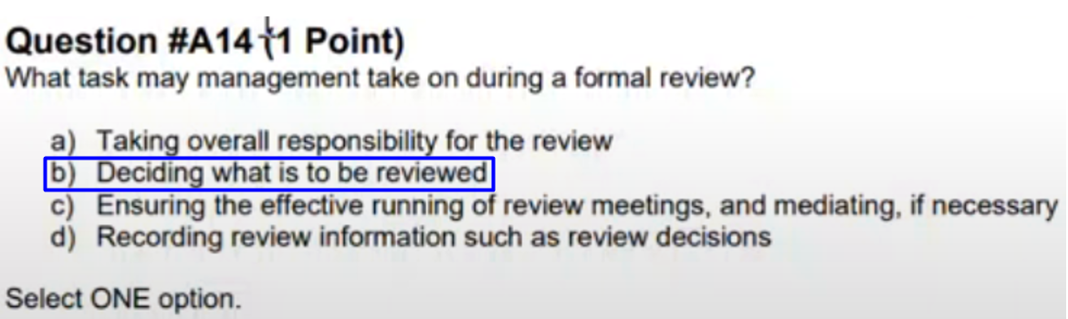

## Question 15

FL Review part2 - start at 48:59

Q15

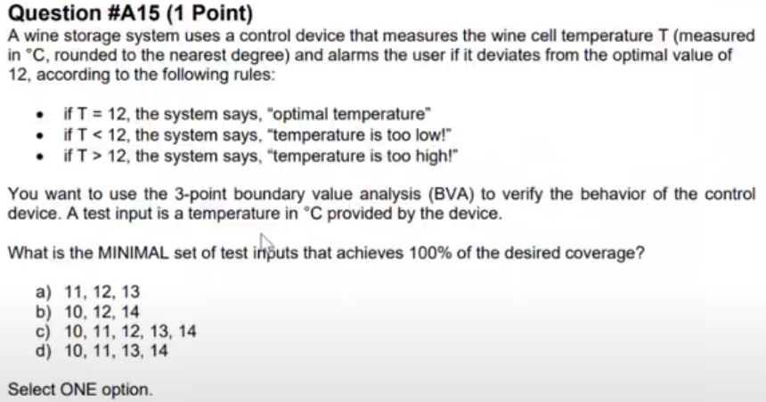

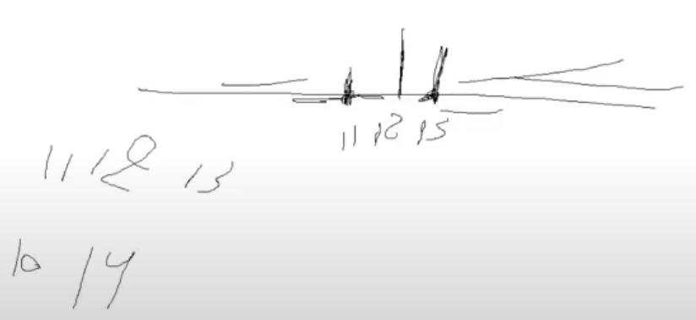

Q15 - Answer

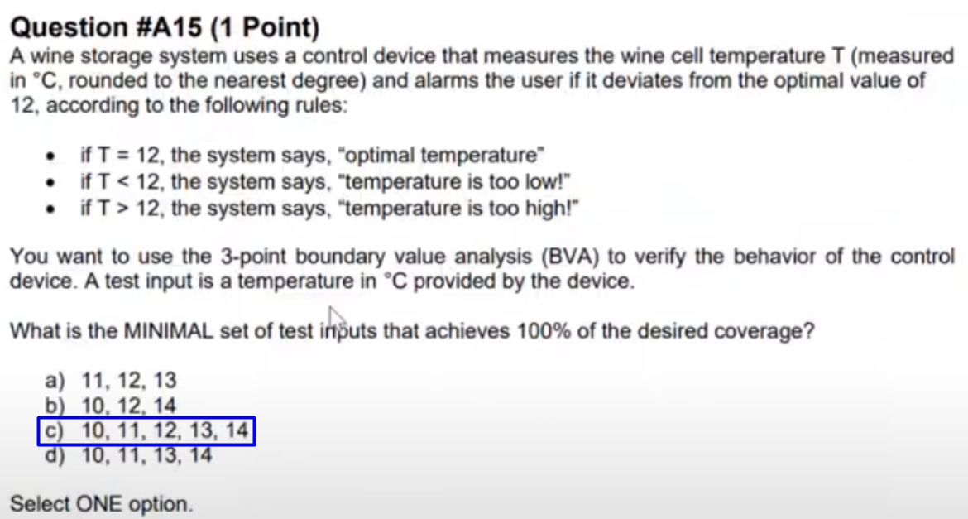

## Question 16

FL Review part2 - start at 54:22

Q16

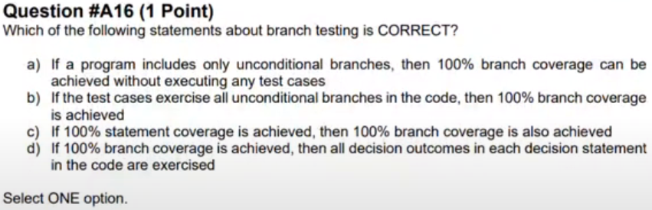

Q16 - Answer

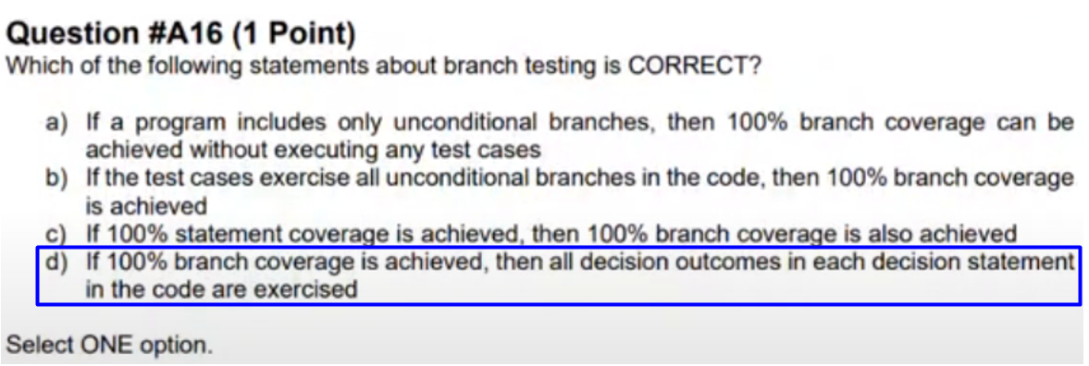

## Question 17

FL Review part2 - start at 56:00

Q17

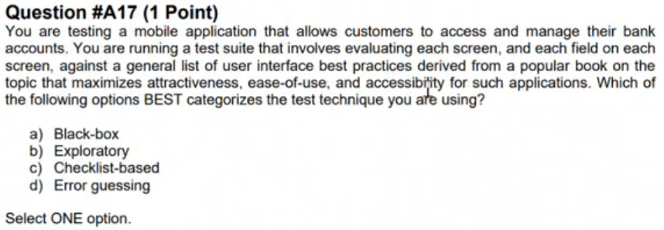

Q17 - Answer

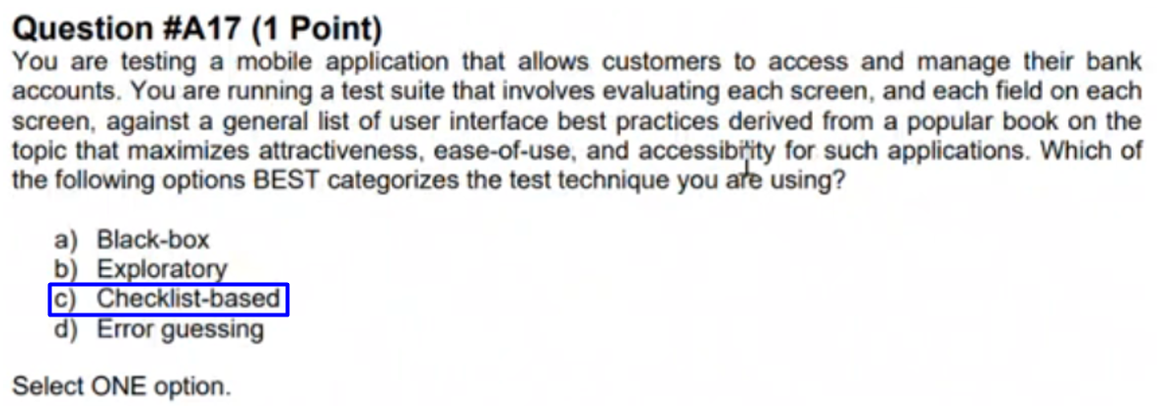

## Question 18

FL Review part2 - start at 57:15

Q18

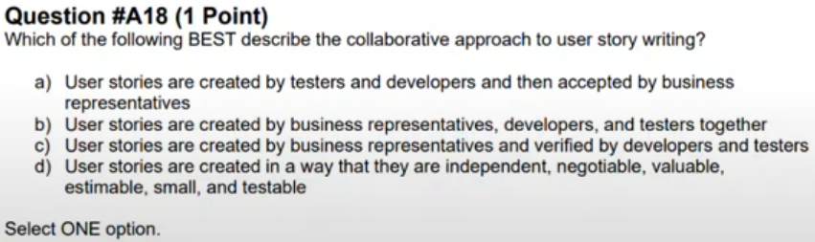

Q18 - Answer

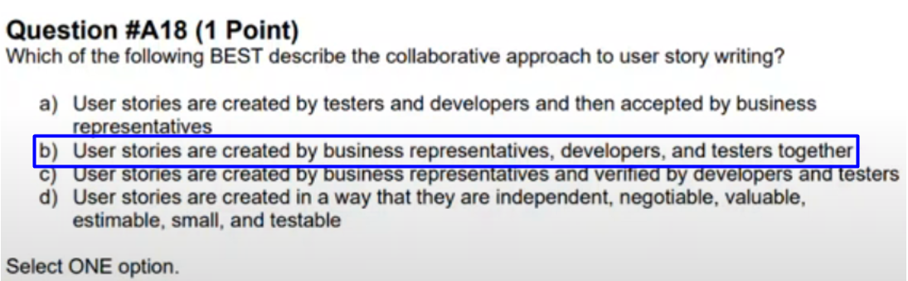

## Question 19

FL Review part2 - start at 1:00:22

Q19

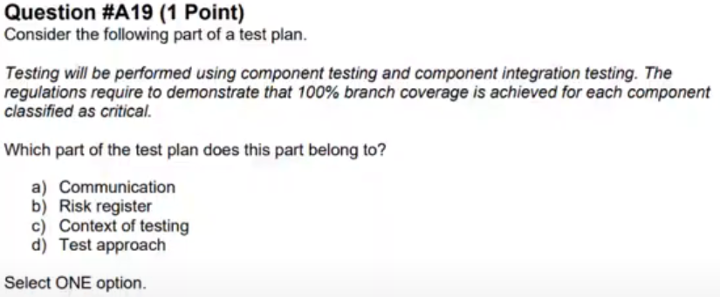

Q19 - Answer

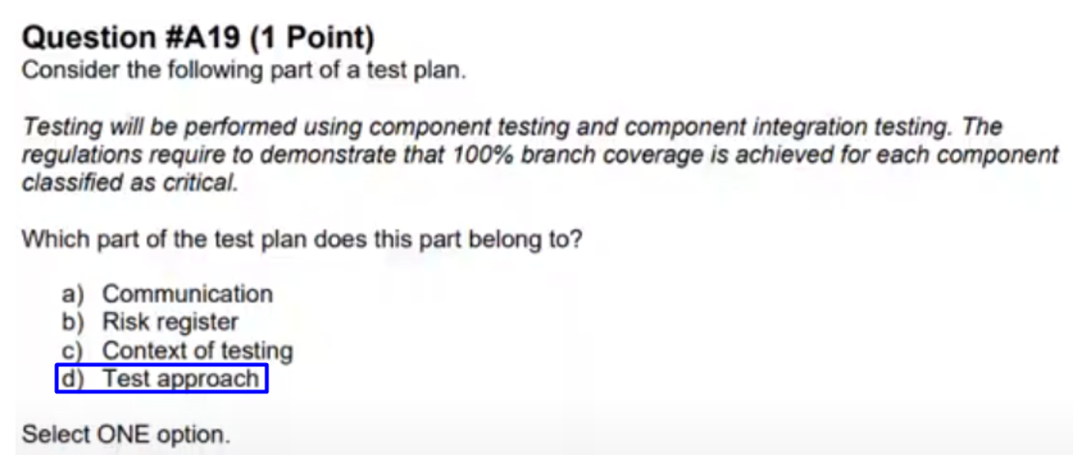

## Question 20

FL Review part2 - start at 1:02:15

Q20

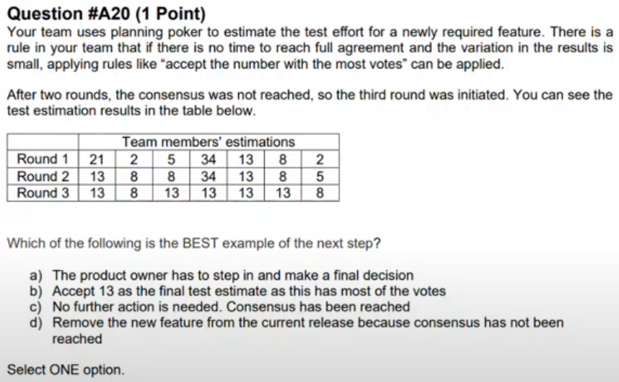

Q20 - Answer

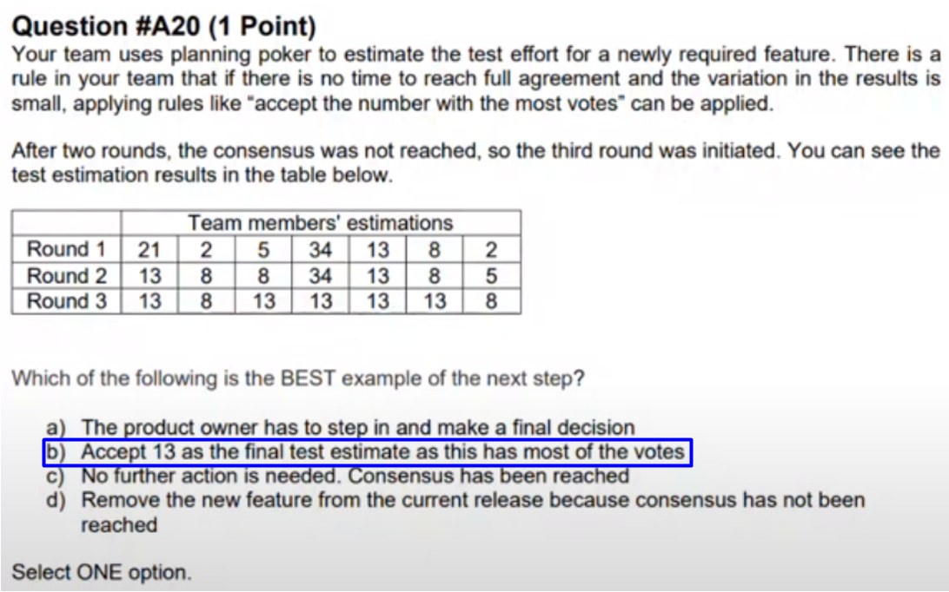

## Question 21

FL Review part2 - start at 1:04:32

Q21

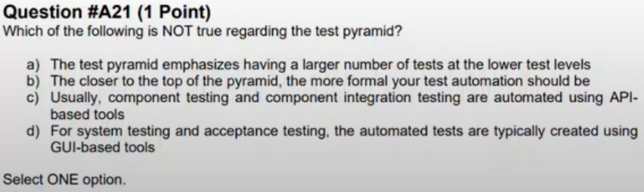

Q21 - Answer

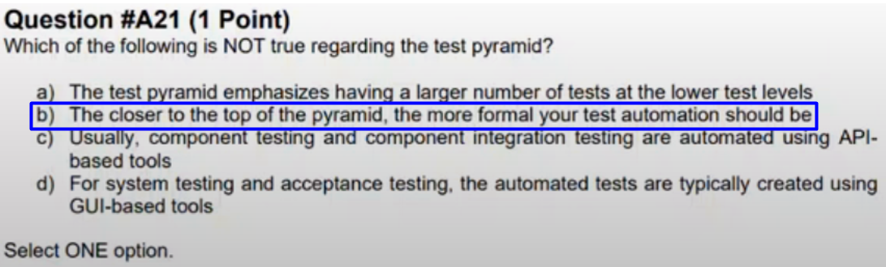

## Question 22

FL Review part2 - start at 1:06:33

Q22

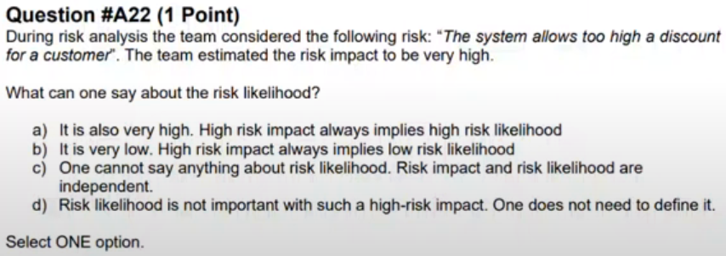

Q22 - Answer

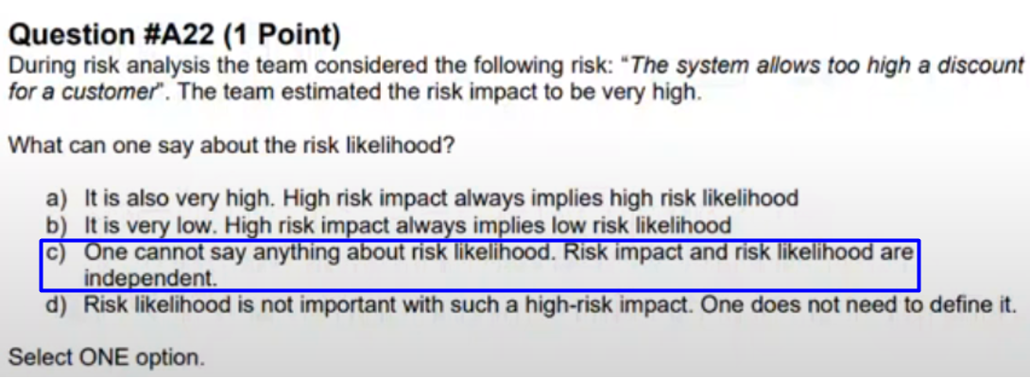

## Question 23

FL Review part2 - start at 1:08:37

Q23

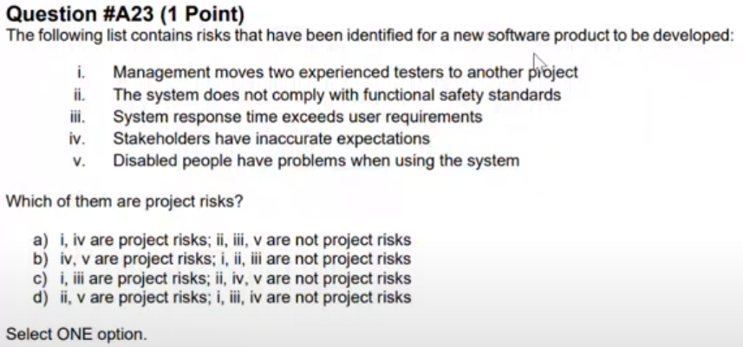

Q23 - Answer

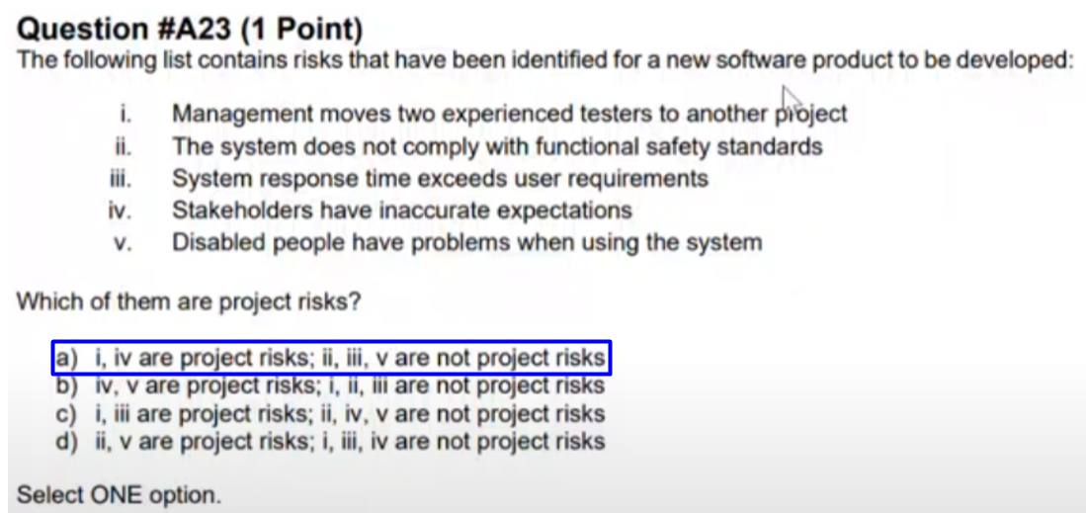

## Question 24

FL Review part2 - start at 1:10:22

Q24

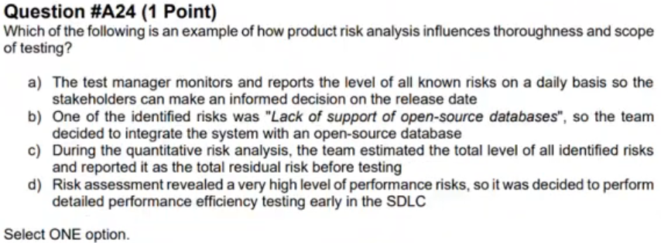

Q24 - Answer

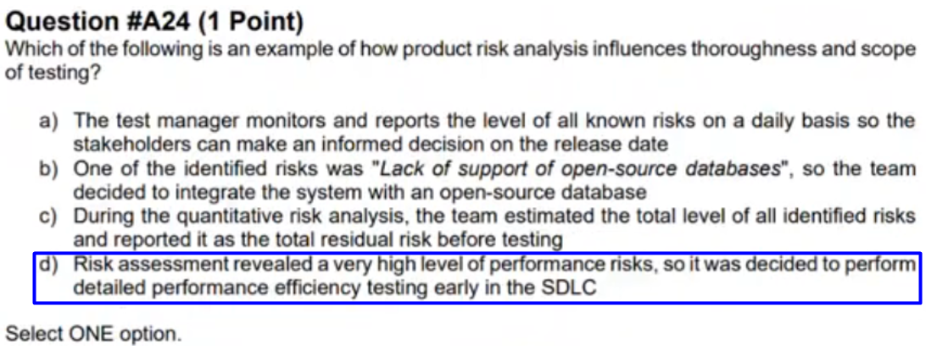

## Question 25

FL Review part2 - start at 1:15:07

Q25

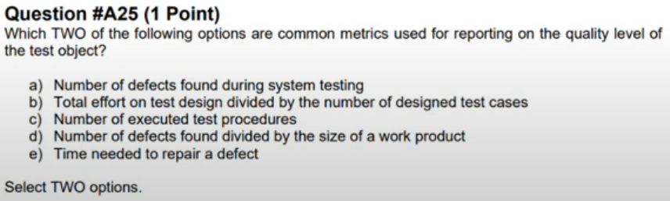

Q25 - Answer

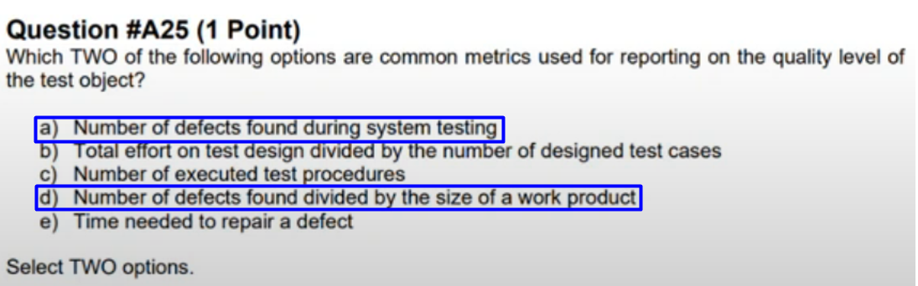

## Question 26

FL Review part2 - start at 1:18:07

Q26

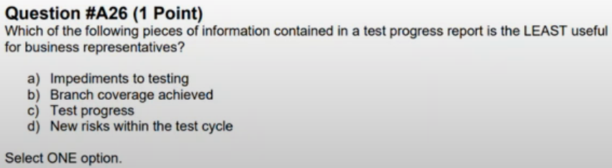

Q26 - Answer

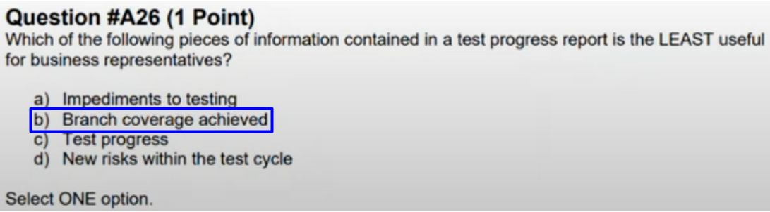

## Question 24 - Again

FL Review part2 - start at 1:20:39



## Question 20 - Again

FL Review part2 - start at 1:25:53



# Questions 2

FL Review part2 - start at 1:29:35

## Question 1

FL Review part2 - start at 1:30:28

Q1

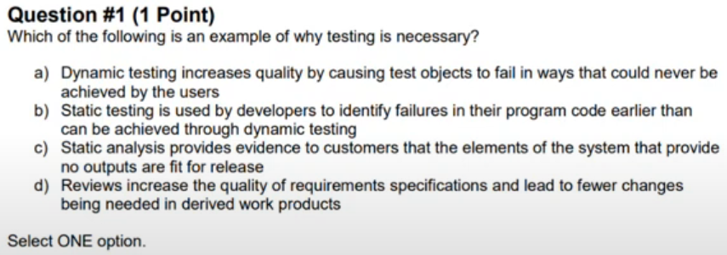

Q1 - Answer

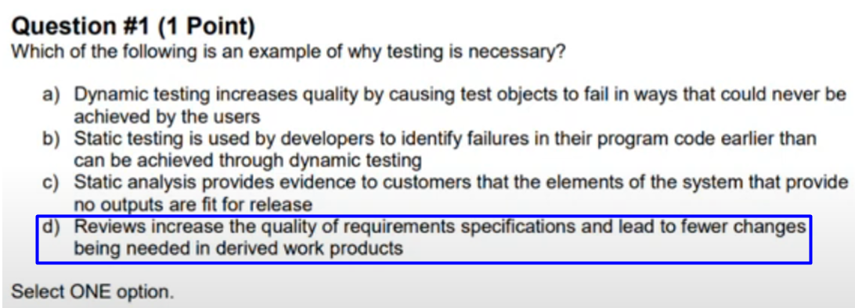

## Question 2

FL Review part2 - start at 1:31:39

Q2

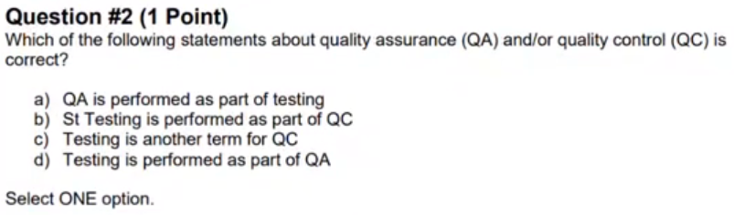

Q2 - Answer

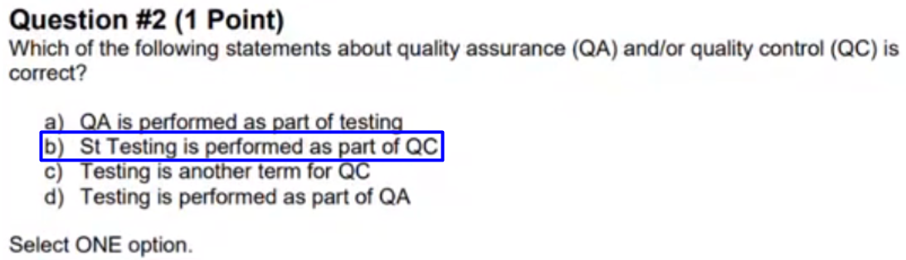

## Question 3

FL Review part2 - start at 1:36:25

Q3

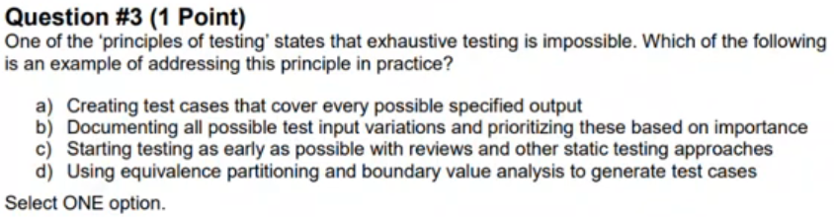

Q3 - Answer

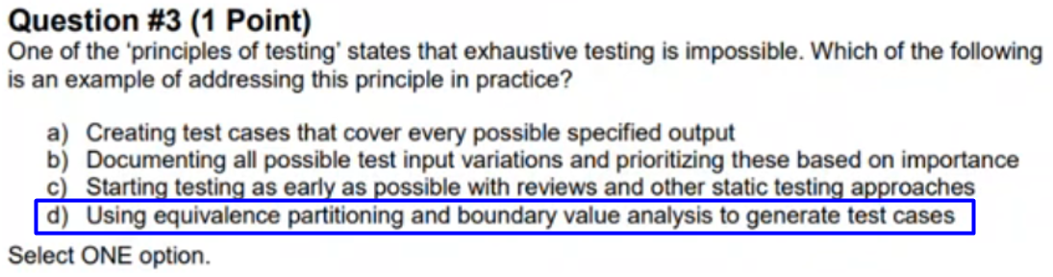

## Question 4

FL Review part2 - start at 1:37:46

Q4

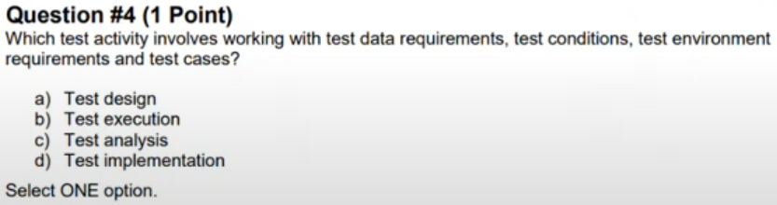

Q4 - Answer

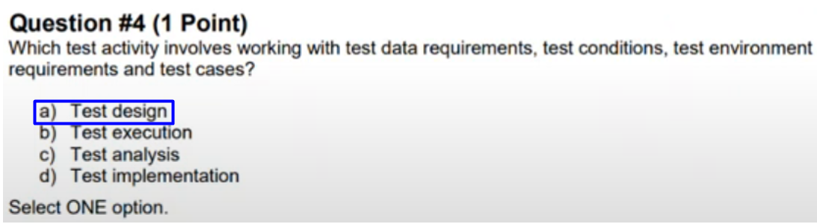

## Question 5

FL Review part2 - start at 1:38:42

Q5

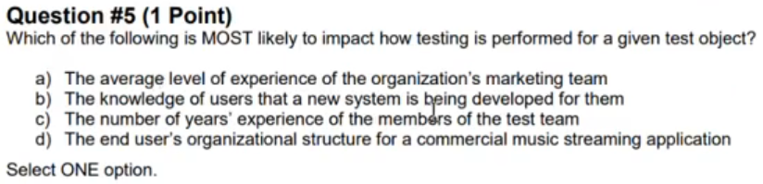

Q5 - Answer

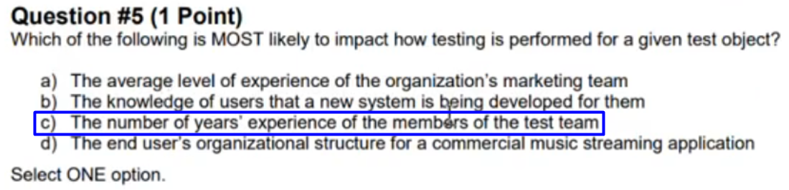

## Question 6

FL Review part2 - start at 1:40:58

Q6

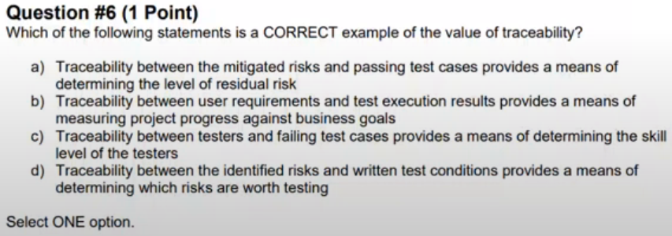

Q6 - Answer

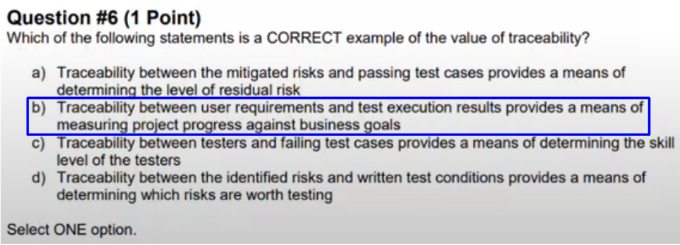

## Question 20

FL Review part2 - start at 1:50:17

Q20

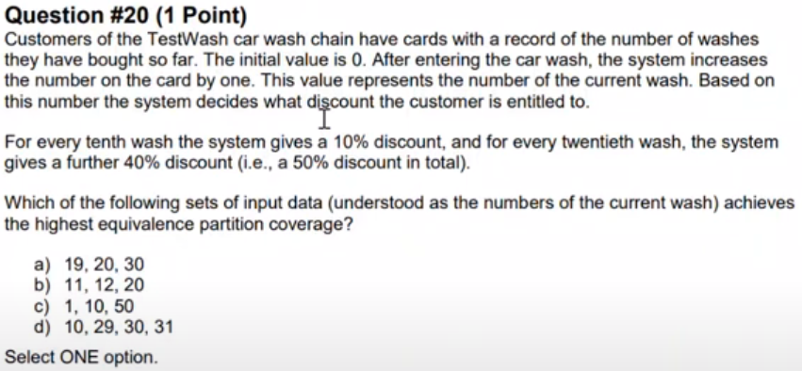

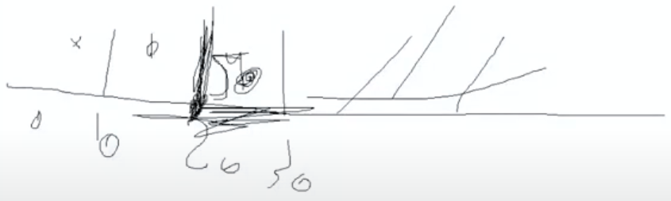

Q20 - Answer

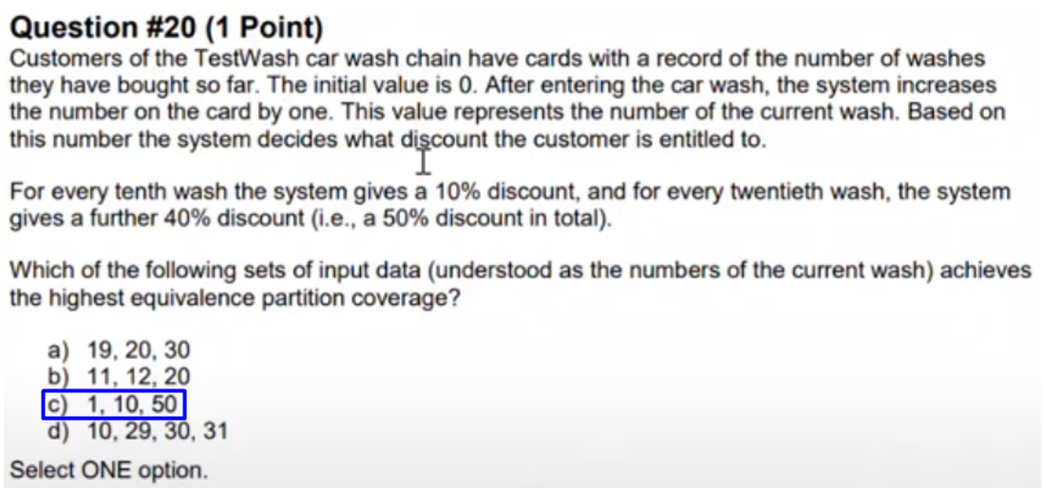

## Question 21

FL Review part2 - start at 1:57:45

Q21

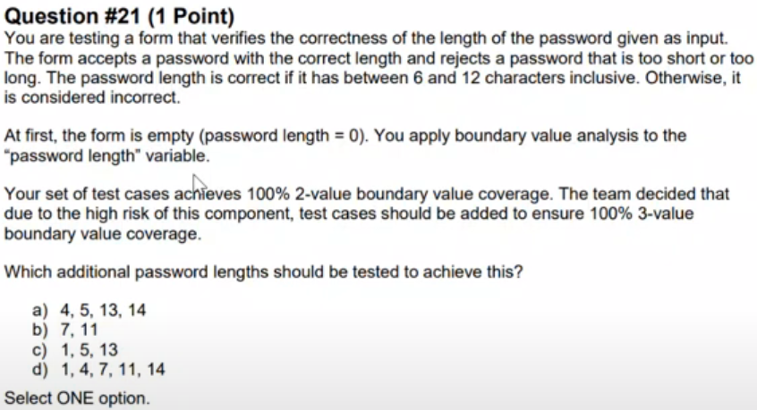

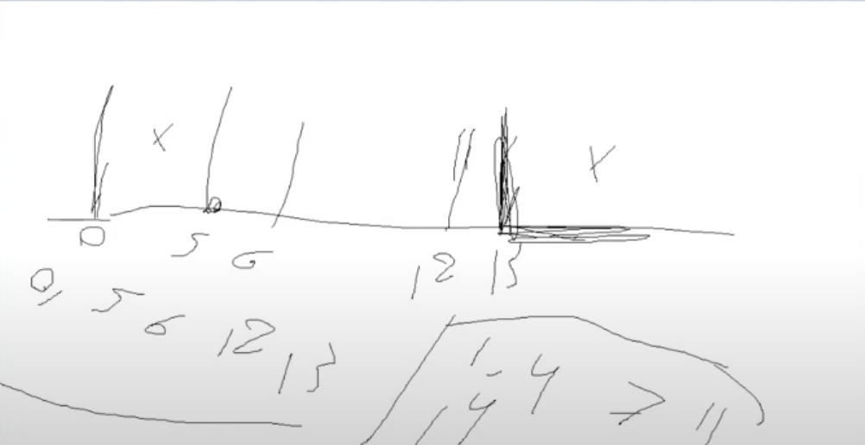

Q21 - Answer

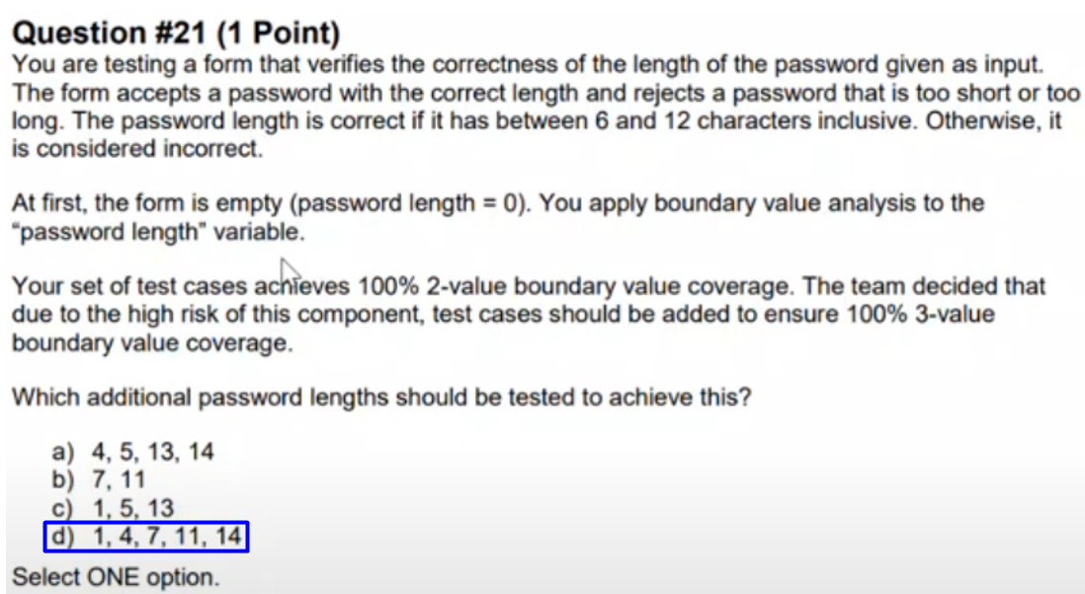

## Question 22

FL Review part2 - start at 2:04:04

Q22

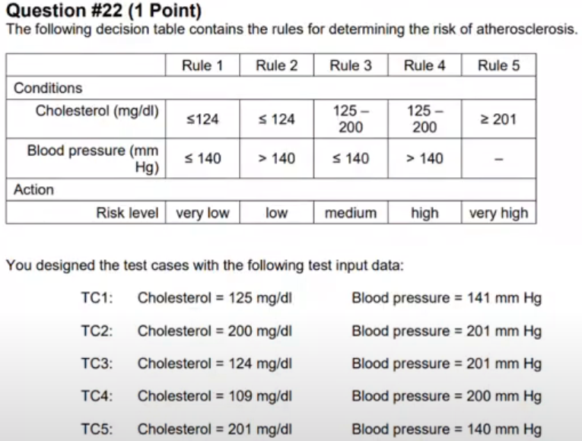

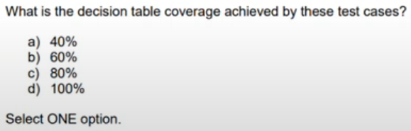

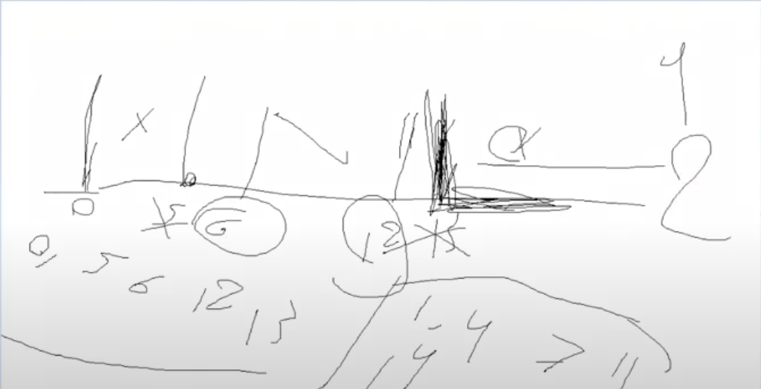

Q22 - Answer

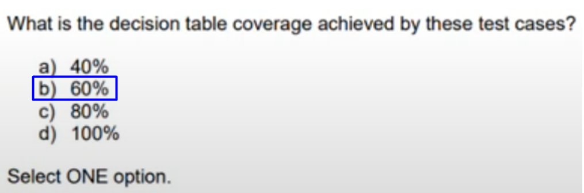

## Question 23

FL Review part2 - start at 2:08:51

Q23

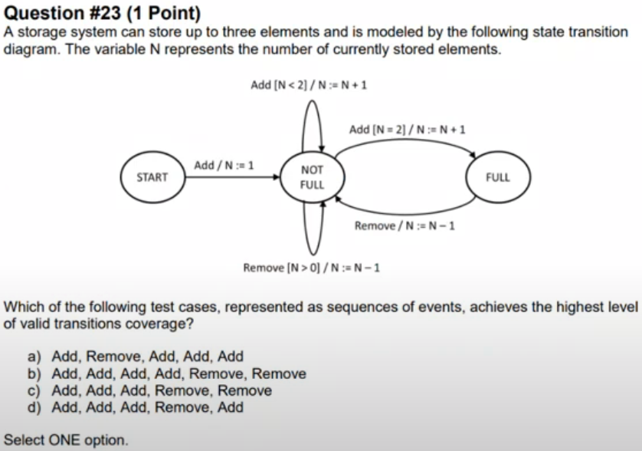

Q23 – Answer

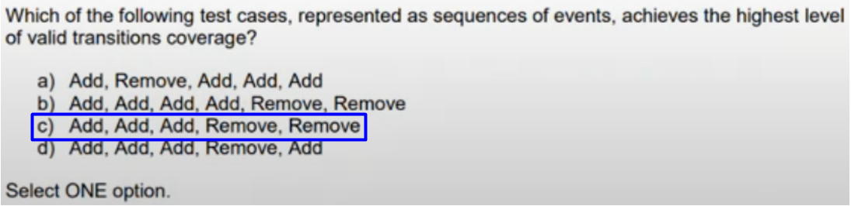

## Question 31

FL Review part2 - start at 2:11:51

Q31

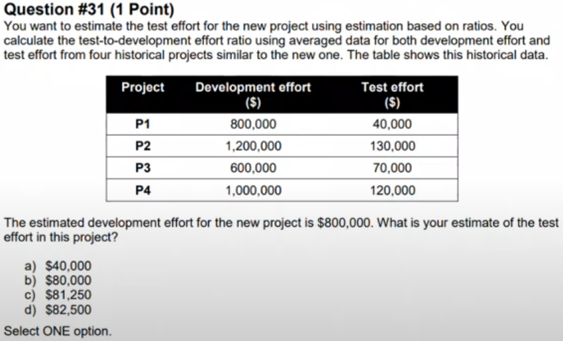

Q31 - Answer

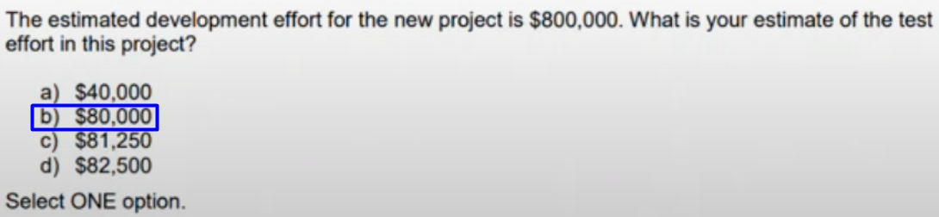

## Question 32

FL Review part2 - start at 2:16:06

Q32

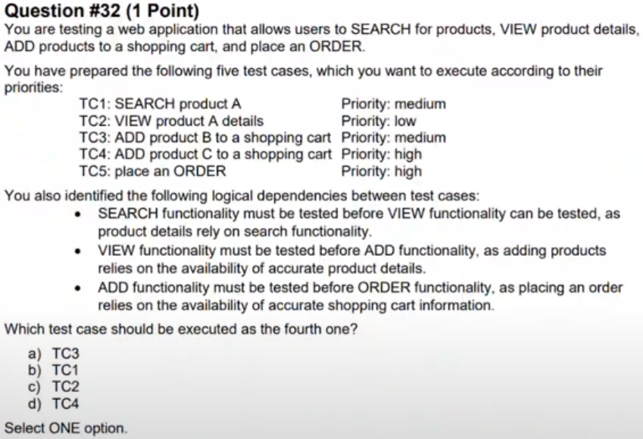

Q32 - Answer

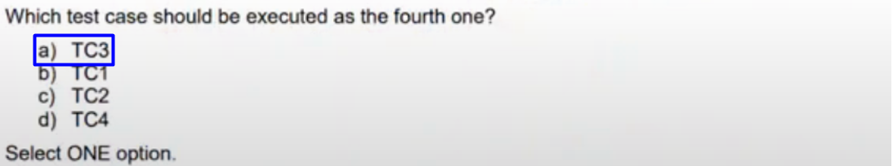

## Question 38

FL Review part2 - start at 2:20:38

Q38

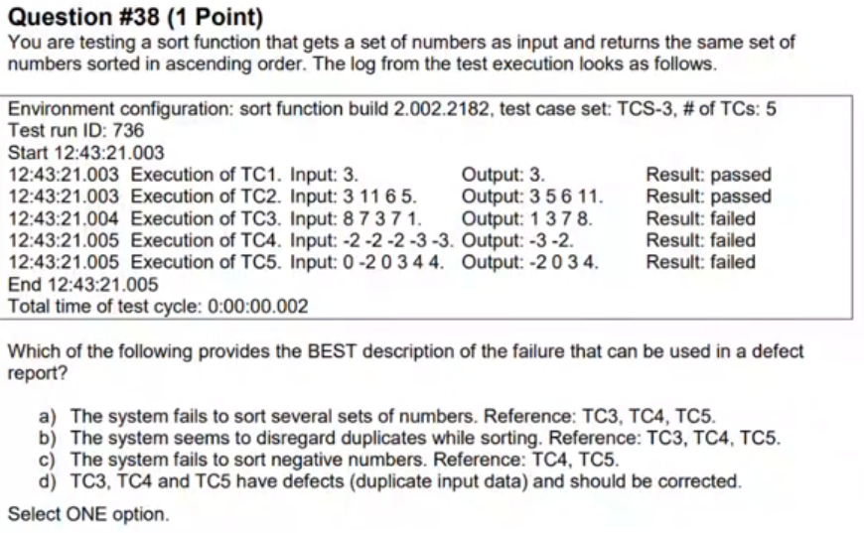

Q38 - Answer

